**Problem :** [**Counting Towers**](https://cses.fi/problemset/task/2413)

**Approach : See video from timestamp if required :**

[**CSES Dynamic Programming: Counting Towers**](https://youtu.be/pMEYMYTX-r0?t=314)

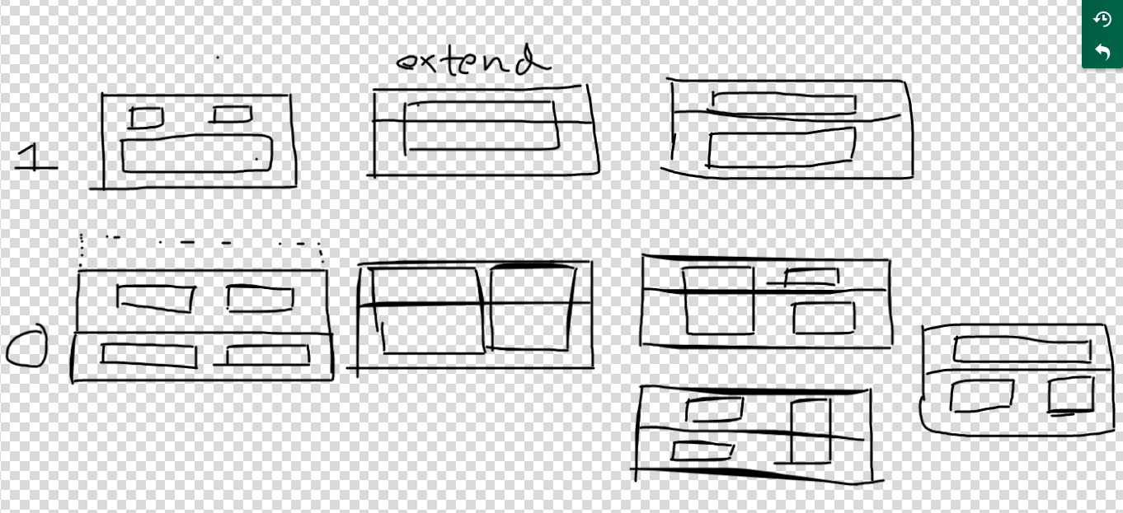

**dp[0][i] = number of combinations possible from ith row , assuming that the blocks in**

**i-1 th row were not linked.**

**dp[1][i] = number of combinations possible from ith row , assuming that the blocks in**

**i-1 th row were Linked.**

If we want tower of height ‘h’ , we will have rows from 0(bottommost) to h-1(topmost).

Let’s say height = 2 , so 2 ros 0 and 1, so dp[0][1]+dp[1][1] will be our answer.**(shown in figure)**

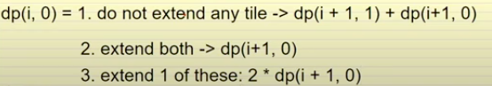

dp(i,1) will be 1. Don’t extend any tile. dp[1][i+1] + dp[i+1][0]

2. Extend both : dp[i+1][1]

**For the Base Case : dp[0][h]=1 ,dp[1][h]=1, try it on example of h=2.**

**Code :** [**https://ideone.com/YQVJaN**](https://ideone.com/YQVJaN)